CurveAlign Users Manual

# Contents

[Contents 1](#_Toc340869349)

[1 Introduction 1](#_Toc340869350)

[2 New output images 2](#_Toc340869351)

[2.1 Overlay image 2](#_Toc340869352)

[2.2 Map Image 3](#_Toc340869353)

[2.2.1 How processed map files are created: 4](#_Toc340869354)

[3 Boundary Analysis 5](#_Toc340869355)

[4 Stacks 6](#_Toc340869356)

[4.1 Stacks with Boundaries 7](#_Toc340869357)

[4.2 Stacks without Boundaries 7](#_Toc340869358)

[5 Status Label 7](#_Toc340869359)

# Introduction

The GUI in CurveAlign is modular, so that the main user interface is in a separate window from the outputs. This allows for the user to resize the output windows to their preferred size. The main user interface window is shown below.

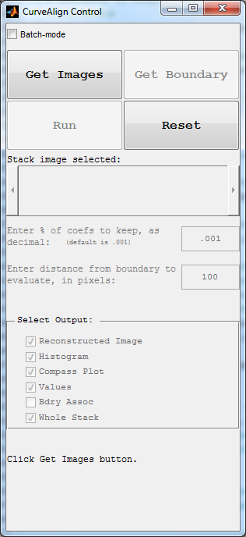

Figure 1. Main user interface for CurveAlign.

# Output images

## Overlay image

This image shows the position and angle of each curvelet that is being used in the analysis (green) and each curvelet that is ignored (red) as an overlay on the original image. If a boundary is selected, the boundary is also included in the overlay.

TACS-3a_overlay.tiff

Figure 2. Overlay image showing the curvelets that are within the specified distance from the boundary in green, the curvelets outside the specified boundary in red, and the boundary in yellow.

## Map Image

The map image is intended to help the user identify the spatial distribution of curvelet angles within the image.

The raw map (\_rawmap.tiff) file codes the angle of the curvelet into a grey scale value. The pixel in the image where the center of the curvelet is located is given a value between 0 and 255 that corresponds to 0 to 90 degrees when a boundary is selected and 0 to 180 degrees when a boundary is not selected. This file may be further processed in matlab or imagej according to the users preferences.

The processed map file (\_procmap.tiff) is a processed version of the raw map file overlayed on the original image. The output is intended to show regions of aligned structures that are perpendicular to the boundary, in the case of a boundary selection, or regions of generally aligned structures, in the case where no boundary is selected.

### How processed map files are created:

When a boundary is selected, the raw map file translates 0 to 90 degrees into 0 to 255 in gray scale. The center location of each curvelet is given a gray level corresponding to its angle with respect to the boundary. Then a square max filter is applied with a size of 12 pixels on a side, followed by a Gaussian disc filter with a sigma of 4 pixels. The color scale is then set to 0-20 degrees = black, 20-45 degrees = green, 45-60 degrees = yellow, and 60-90 degrees = red. The map image is overlayed on the original image with transparency set to 0.5. See Figure 3.

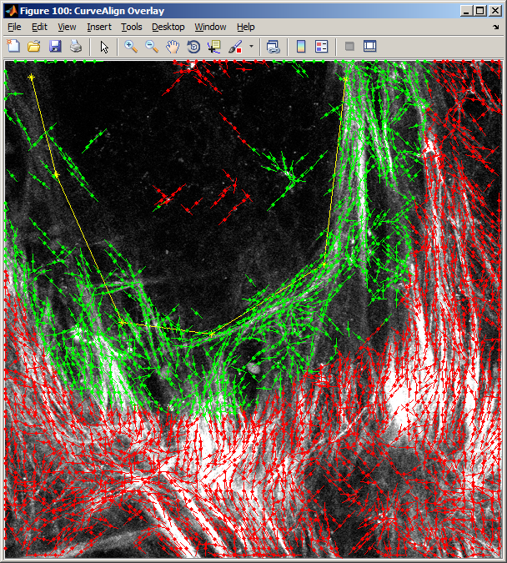TACS-3a_procmap.tiff

Figure 3. Over lay (left) and map (right) images when a boundary is selected.

When a boundary is not selected, the raw map file translates 0 to 180 degrees into 0 to 255 in gray scale. The center location of each curvelet is given a gray level corresponding to its absolute angle in the image. Then a square, standard-deviation filter is applied with a size of 64 pixels on a side. The result is then subtracted from 127.5 (half of 255), followed by a 12 pixel max filter, followed by a Gaussian disc filter with sigma of 4 pixels. The color scale is then set to 0-80 black, 80-90 green, 90-100 yellow and 100-127.5 red. In this case, red indicates areas of highly aligned structures, while black and green indicate areas of more randomly aligned structures. The map image is overlayed on the original image with transparency set to 0.5. See Figure 4.

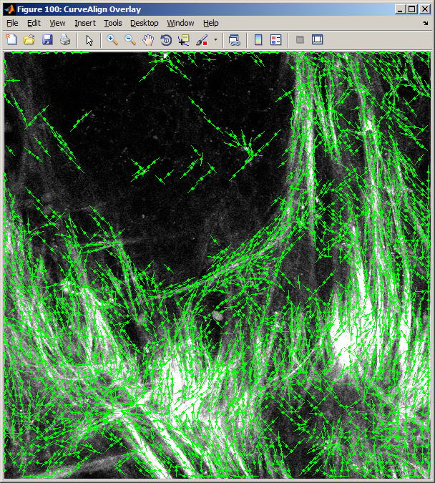TACS-3a_procmap.tiff

Figure 4. Overlay and map images when no boundary is selected.

# Boundary Analysis

The user is now able to analyze the curvelets that fall only within a certain distance from a boundary. To enter this distance, first a boundary must be drawn or opened from file. Then the distance in pixels should be entered into the edit box.

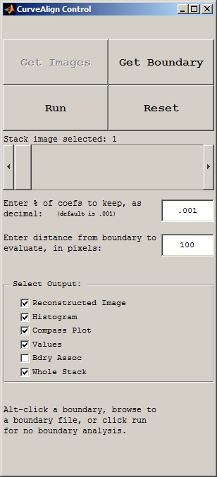

Boundaries are created by alt-clicking on the original image that is opened in the CurveAlign GUI. When alt is released, the boundary is ended and no additional points may be added to the boundary. Boundary files can also be opened by browsing to a saved boundary file using the Get Boundary button.

The position on the boundary that is being compared to each curvelet may be visualized as well. This allows the user to see where the angle comparisons are being made. Blue lines are drawn on the overlay output image from each curvelet to the point on the boundary that the curvelet is associated with.

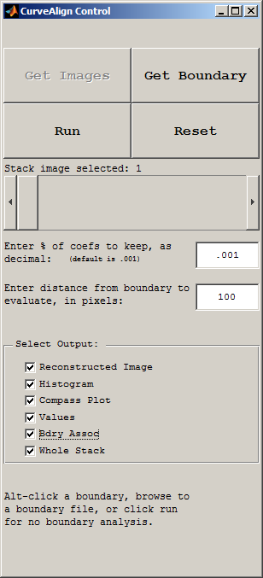

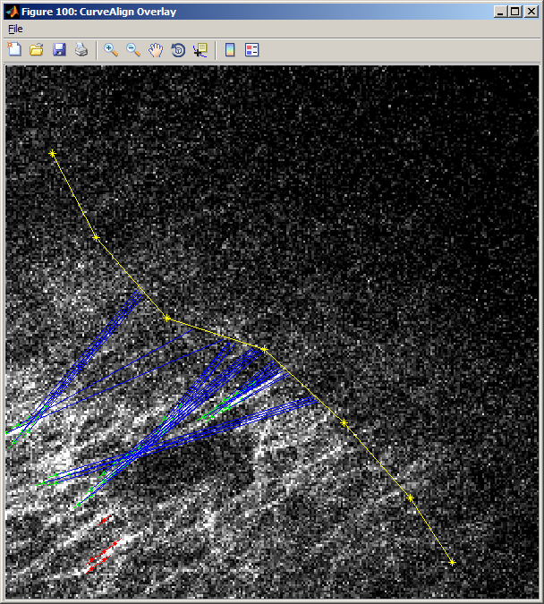

Figure 5. An example of an overlay images where the associations between curvelets and the boundary are indicated by blue lines.

# Stacks

CurveAlignV2.0 allows for the user to select stacks of images. When a stack is opened, the slider bar is enabled, allowing the user to choose which image in the stack should be displayed.

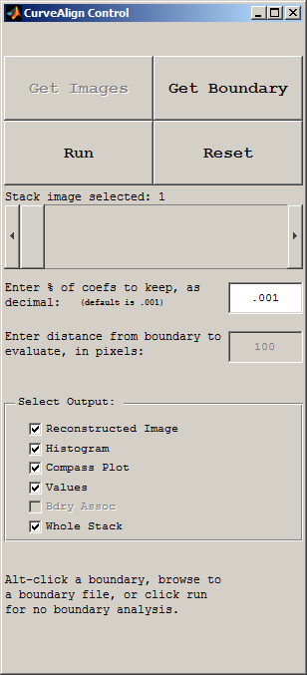

There is a checkbox at the bottom of the main window that allows for the user to select if the whole stack should be processed, or only the current image should be processed.



When a stack is being analyzed, then the output files that are images will also be in stack format. To open these stacks in ImageJ, the LOCI bioformats importer must be used. For some reason, these tiff stacks cannot be drag and dropped into ImageJ, this will be investigated further in the next release of CurveAlign.

The other output files, for example the histogram file and the curvelet angle spreadsheet, are produced such that each image in the stack creates a new output file. For example a stack with 4 images will generate 4 histogram files named stack\_1\_hist.csv, stack\_2\_hist.csv, stack\_3\_hist.csv, etc.

## Stacks with Boundaries

If a stack is being processed, then only a single boundary can be used for the entire stack. Future versions of this tool will allow for a different boundary in each image plane in a stack.

## Stacks without Boundaries

When no boundary file is selected, then each image in the stack is analyzed as described in the section above about image analysis without a boundary.

# Batch mode

Batch mode is used to process entire directories of images and potentially their associated boundaries. Check the “Batch-mode” checkbox and click Get Images to start batch mode.



# Status Label

To allow the user to keep track of what is happening in the program, there is a status label on the bottom of the main window. This label give hints about what the user should do next or shows the current task that the program is working on.

